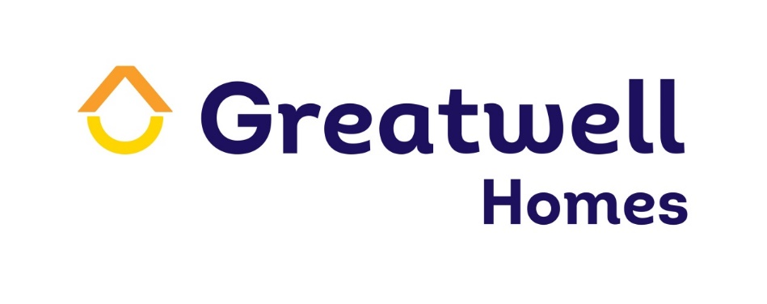
Invitation to Express an Interest in joining Greatwell Homes’ Sub Contractors Support Network Preferred Suppliers List

Date notice publication | 15th January 2020
Deadline for receipt of quotation proposals | 17:00 on 10th February 2020

- Background
Greatwell Homes was created as Wellingborough Homes in 2007 after a Large Scale Voluntary Transfer (LSVT) to own and manage Wellingborough Borough Council’s housing stock; now managing more than 80 per cent of the social housing stock within Wellingborough and the 15 surrounding villages. With over 4800 homes in ownership and 125 employees we are the largest local landlord within the Borough of Wellingborough and continue to expand across the Borough borders. After over 11 years as Wellingborough Homes much had changed so the decision was made to change the name to reflect our ambitions to grow into the wider Northamptonshire area and transition into a more digital-based organisation. The name Greatwell Homes was chosen because as an organisation we are committed to proving great services and high quality living environments, and even though we are growing, Wellingborough and surrounding areas will always be an important part of who we are.

1.1 Who we are and what we do:
We are a locally based Housing Association in and around Northamptonshire with a commitment to:
● Develop a diverse range of new homes to meet local needs.
● Work with our customers to provide great homes and value for money services.
● Invest in communities where it supports our customers and protects our business.

1.2 Our Mission and Objectives

“Working successfully with our customers and communities to
provide great services and high quality living environments”.

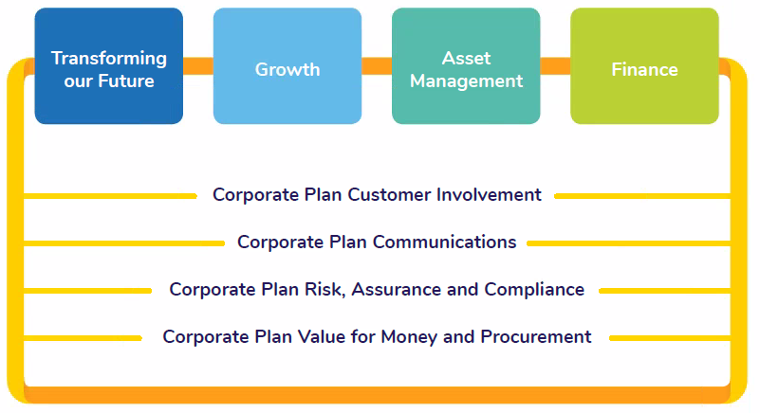
We will achieve our Mission by delivering our four corporate strategies, underpinned by our four corporate frameworks:

Our Values

Our style of work, and the values our team members express everyday, are key to our success. We expect anyone working for us or on our behalf to live our values of:
Respect:
We will treat each other and anyone who deals with us with respect and recognise everyone as an individual.
Trust:
We will be open and honest with our colleagues, customers and external partners and we will deliver on the commitments that we make.
One Team:
We will be one team, working collaboratively, listening and communicating clearly with our customers to deliver great services.
Empowered:
We will be bold, progressive, seek to empower our customers and be confident in the decisions we make.
Efficient and Effective:
We will work efficiently and effectively, continuously looking for ways to improve and deliver value for money.

Greatwell Homes is a not for profit housing association.

For further information about Greatwell Homes please refer to our website at www.greatwellhomes.org.uk

2. The Key Aims, Objectives and Outcomes
Greatwell Homes is looking to set up a Preferred Suppliers List (PSL) of local building trades contractors who will be able to provide ad hoc services complementing our in-house repairs, maintenance and voids teams. On 1st April 2017 Greatwell Homes successfully launched an in-house Repairs and Maintenance Service, followed in April 2018 with bringing the Voids Service in-house. While these services are running successfully it is recognised that on occasion, due to the quantity and type of work, sub-contractors are needed to ensure that the work is completed to corporate deadlines and to meet our customer expectation and satisfaction. Rather than this sub-contracting work being carried out on a piecemeal basis and to increase the efficiency of our services we are looking to put together a PSL of vetted contractors that can be called upon when necessary producing the following outcomes:
- Increase services and efficiencies and improvements;
- Improve Customer Satisfaction;
- Achieve Value for Money;
- Develop a strategic partnership with a supplier who will deliver social value within the community.

2.1 Areas of work we are looking to cover
The areas of work we are hoping to cover but not limited to, are:
1. Groundworks
2. Fencing
3. Plastering
4. Void works (multi trade)
5. Clearance
6. Cleaning
7. Electrical
8. Glazing
9. Lock smith
10. Drainage
11. Pest control
12. Flooring
13. Bricklaying
14. External works i.e. paving; tarmacking
15. Electrical appliance/white goods replacement and servicing.
16. Fire risk assessment and remedial works

3 The Contractors (Supplier)
If you would like to be considered as a supplier for inclusion on the PSL, please provide answers to the following questions (maximum work count for each question is 250 words)

Q1
Company name:

Location and areas covered:

Contact Name:

Contact phone number:

Contact email:

Q2
Please identify the areas of work you would wish to be considered for (you can identify more than one area – see section 2.1) and provide details of previous work carried out in those areas:

Q3
Please provide details of how your business can provide adequate personnel to ensure that the works and admin support can be covered, Please provide any details of training:

Q4
Please detail how you would set Price Schedule of rates (SOR’s) NHF 6.1 +/- %:

Q5
Please provide Insurance Policies, core H & S policies, generic relevant
risk assessments with accompanying safe systems of work, relevant
qualifications of personnel and industry/professional body accreditation
of your organisation. In addition please disclose any enforcement action
that have been undertaken against your organisation, company or personnel, such as the Fire Service, Health and Safety Executive or a local authority.
(Note: You will be asked to produce the documentation if accepted onto the PSL)

Q6
If applicable, please provide any details of how you have worked with
Greatwell Homes previously:

Q7
Please provide examples of where you have successfully worked with
organisations similar to Greatwell Homes:

Q8
Please provide details of how you would work with Greatwell Homes to ensure any work is completed successfully and on time:

Q9
Please detail how your company values fit in with Greatwell Homes’ organisational values, to ensure an effective working relationship:

Q10
Please provide any other information you feel may be relevant:

4 Evaluation Criteria
When evaluating your responses, we will be considering a number of criterions, including but not limited to:
- Previous working relationships/experience with Greatwell Homes
- Cost
- Value For Money
- Sector understanding
- How you will work with us moving forward
- Sustainability/Social Value
- Customer Care

Based on your responses to the above questionnaire, you may be invited to a second stage meeting to discuss Greatwell Homes’ PSL requirements in more detail.

If you are invited through to the second stage we will be asking you to provide relevant references.

If you are unsuccessful following this questionnaire, we will notify you prior to these meetings.

We will not meet or discuss any details with suppliers outside of this process.

Important information
Selection for the PSL does not guarantee you will be chosen to carry out a set number jobs, or any work for Greatwell Homes. As work becomes available a supplier from the list will be chosen based on its suitability to complete the work to a given timescale to an expected standard offering the best value for money.
However, Greatwell Homes does undertake to share the available work between all the suppliers on the PSL.

5 Evaluation Panel
The evaluation panel will comprise of the following

Job Title | Role
Head of Property Services | Panel Member
Asset and Compliance Manager | Panel Member
Repairs and Maintenance Manager | Panel Member
Project Surveyor | Panel Member

6 Timetable
The following timetable will be adhered to:

15th January 2020 | Dispatch invitation for expression of interest
17:00 10th February 2020 | Deadline for return of expression of interest
Week beginning 2nd March 2020 | Follow-up meetings for invited suppliers
From 6th April 2020 | Start PSL

7 Instructions to interested Suppliers

Disclosure of information

All information supplied by Greatwell Homes in connection with this invitation must be treated as confidential and should not therefore be disclosed to any third party. Greatwell Homes will treat any information supplied by firms during this process in the strictest confidence.

Validity of offer
Please note that by submitting a response for consideration you are confirming that, as an officer for the company/organisation that you represent, you have read and understood this document.

Amendments to Process
If we need to amend any areas of this invite for expressions of interest before the closing date, we will write to you with any changes. If we extend the deadline for responses, we will advise you.
Greatwell Homes reserves the right, in its absolute discretion, to cancel or suspend this process at any time and for any reason. If we need to do this we will notify you in writing as soon as reasonably practicable.
Greatwell Homes is not responsible and will not pay for any expenses or losses you incur during, including but not limited to, preparation, site visits and/or post-tender clarification meetings.

8 Submission of expression of interest

All expressions of interest must be sent via email to

procurementteam@greatwellhomes.org

by

14.00 noon on 10th February 2020

Receipt of submission will be confirmed by email
No expression of interest will be accepted if received after the above date and time.

