Pet Ownership Procedure
Linked policies | Pet Ownership Policy
Version | 1.0
Date approved by | Head of Housing & Neighbourhoods (May 2022)
Date effective from | May 2022
Date of next review | May 2025
Procedure owner | Housing and Income Services Manager

1 | Introduction
1.1 | Owning a pet has a multitude of benefits, from companionship, increased wellbeing, and opportunities for socialising with others.
1.2 | Whilst we recognise that most people are responsible pet owners, there are a number of issues that may highlight disagreements between customers, and housing management issues for our staff.
1.3 | This procedure sets out to ensure that pet ownership is managed effectively between staff and customers at Greatwell Homes, providing clarity for customers on what responsibilities they must adhere to, in order to own a pet.
2 | Legislative Context
2.1 | - The Animal Welfare Act (2006)  - Dangerous Wild Animals Act (1976)  - Dangerous Dogs Act (1991)  - Anti-social Behaviour, Crime and Policing Act (2014)  - Control of Dogs Order (1992)
3 | Scope
3.1 | This procedure applies primarily to staff in the neighbourhood housing and customer services teams.
3.2 | This procedure applies to all customers, regardless of tenure.
4 | Definitions
4.1 | Pet - a domestic pet whose purpose is companionship, and which is defined as: a dog (excluding those prohibited by the Dangerous Dogs Act 1991, or any other law), cat, bird, fish, small, caged rodent, small non-poisonous caged reptile, non-poisonous contained insect, or amphibian
4.2 | Exotic Pet - a non-domestic pet that is not native to the country where it is kept in captivity.
4.3 | Livestock - cattle, horses, goats, sheep, fowl, poultry, and similar animals kept for domestic use
5 | Applying for a Pet
5.1 | Customers who wish to apply for a pet must submit an application form to the customer services team. This form contains an addendum to the tenancy agreement that defines the new conditions that the customer must agree to, to own a pet in their home.
5.2 | Only signed forms will be accepted. Where requests are made by joint tenants, we will expect both joint tenants to sign.
5.3 | Upon receiving an application form, the customer services officer (CSO) will confirm receipt to the customer (either by phone or e-mail) and forward the application to the relevant neighbourhood housing team.
5.4 | Upon receipt of the completed application form, the neighbourhood housing officer (NHO) will consider the application and make a decision to approve or not.
5.5 | When considering requests for these animals as pets, the NHO must consider the following  - Noise generated by the animals in question and impact on neighbours  - Garden size (micro pigs require significant garden size to live comfortably for example)  - Other potential nuisance issues to neighbours  - The number of pets already located at the property in question  - The ability of the customer to care for and clean up after their pet.
5.6 | The following pets are not permitted under our policy and approval must not be given in any circumstances.  Refusals  Pit Bull Terrier Banned under Dangerous Dogs Act (1991)  Japanese Tosa Banned under Dangerous Dogs Act (1991)  Fila Brasileiro Banned under Dangerous Dogs Act (1991)  Dogo Argentino Banned under Dangerous Dogs Act (1991)  Cattle / Calves Our policy does not permit Livestock as pets  Sheep / Lambs Our policy does not permit Livestock as pets  Horses / Ponies Our policy does not permit Livestock as pets  Goats / Kids Our policy does not permit Livestock as pets  Hawks / Eagles Our policy does not permit birds of prey as pets  Owls Our policy does not permit birds of prey as pets  Falcons Our policy does not permit birds of prey as pets  Other Birds of Prey Our policy does not permit birds of prey as pets  In addition, animals that require a license under the Dangerous Wild Animals Act (1976) are not permitted as pets. An abridged list of such animals is provided below.  Animals that require a license  Monkeys and Primates Venomous Snakes  Kangaroos Widow Spiders  Wild Dogs, Wolves and Jackals Wandering Spiders  Wild Cats Violin Spiders  The full list may be found at the following link if there is any doubt  https://www.legislation.gov.uk/uksi/2007/2465/schedule/made
5..7 | Once a decision has been made, the NHO will send a letter either approving or denying the request. There is no right of appeal against this decision and any complaints will be managed through our customer concerns and complaints procedure.
5.8 | Once a decision has been made, the NHO will save a copy of the appropriate letter on the dwelling file in the ‘H’ drive and update Orchard with a UDC to indicate the how many pets the customer has, and what type of pets they are (where appropriate).
5.9 | The NHO must also arrange for the customer to sign an amended tenancy agreement (where approval is given) and this must be signed before the customer purchases their pet.
6 | Management of Pets in Our Homes
6.1 | Once approval is given for a pet, the customer will have signed an addendum to the tenancy agreement. The purpose of which is to supersede any restrictions set out by the existing tenancy agreement or lease and set out the new obligations placed on the pet owner.
6.2 | Should there be any complaints regarding pet ownership (for example excessive noise or damage) the NHO must follow our ASB policy and procedure to manage these cases.
6.3 | The current policy states that we may not class dog barking as ASB, unless it linked to possible neglect or at unreasonable hours. NHO’s must bear this in mind when undertaking investigations.
6.4 | In line with our ASB procedure, NHO’s must try to resolve cases informally, using tools such as informal meetings, mediation, ABC’s and written warnings.
6.5 | Should a case not be resolved informally, and behaviour continues, then the NHO may request that the pet owner re-home their pet. This must be done in a reasonable timescale, balancing the animal’s welfare with the ongoing nuisance.
6.6 | If the customer fails to re-home their pet within the agreed timescale without good reason, then the NHO will refer the case to the community safety team for injunctive relief through the court.
6.7 | When taking cases to court, the community safety officer must complete an equality impact assessment to ensure that we do not discriminate. All equality impact assessments must be signed off by the support services manager.
6.8 | Should complaints involve a guide dog or emotional support animal, then the investigating officer must take advise from relevant experts as part of their initial investigation. This might be the Guide Dogs for the Blind or other agency that has played a part in placing the animal in question.
6.9 | Where the NHO has evidence of pets causing damage to Greatwell Homes’ properties, or evidence of pets urinating or defecating in communal spaces then they must request the customer cleans up after their animal.
6.10 | Where customers are either unwilling or unable to clean the area to an acceptable standard, then the NHO must arrange the appropriate recharge with Greatwell Places and pass on to the customer.
7 | New Customers and Transferring Customers
7.1 | When customers join Greatwell Homes as a new tenant or undertake an internal transfer, the lettings officer must create a new UDC to reflect the types and numbers of pets in the household. The UDC types are linked to tenancies, which means that pets will not appear when a tenancy ends.
8 | Data and Record Management Systems
8.1 | Customer data (including pet ownership) is held on the Orchard Housing Management System. Copies of pet applications are stored on the relevant dwelling folder on the ‘H’ drive.
9 | Performance Management
9.1 | There are no KPI’s or OPI’s that relate specifically to this procedure.
10 | Responsibility and Decision Making
10.1 | The tables below illustrate the structure for responsibility and decision making in relation to this procedure
Person Responsible | Scope
Head of Housing and Neighbourhoods | - Responsible for updating this policy in line with legislative changes, and in line with the policy tracker.
Housing and Income Services Manager | - Overall responsibility for ensuring that all activities are undertaken, and all performance measurements are met
Housing Team Leader | - Responsible for the day to day application and adherence to this policy  - Responsible for providing advice and guidance to officers on matters of discretion
Community Safety Officer | - Responsible for enforcing the tenancy agreement through the courts where informal resolution is not successful.
Lettings Officer | - Responsible for decision making relating to requests for pet ownership in line with this policy and procedure (for new nominees and transferring customers)  - Responsible for communicating decisions to customers  - Responsible for ensuring relevant paperwork is saved on the relevant dwelling file and ensuring that Orchard is updated.
Neighbourhood Housing Officer | - Responsible for decision making relating to requests for pet ownership in line with this policy and procedure (for existing customers)  - Responsible for communicating decisions to customers  - Responsible for ensuring relevant paperwork is saved on the relevant dwelling file and ensuring that Orchard is updated.  - Responsible for managing matters associated with nuisance and ASB in our homes relating to pet ownership
Customer Services Officer | - Responsible for receiving applications for pet ownership and forwarding them to the relevant area team.

11 | Review
11.1 | These procedures will be reviewed to comply with any changes in good practice, legislation, or regulation, and in line with the relevant current policy which will be no less than once every three years.
12 | Appendix One
12.1 | Orchard Notes (Adding UDC’s for pets)
12.1.1 | Adding a Cat to a Household  Go to the Tenancy. Click on the Tenancy UDCs Tab. Click Add  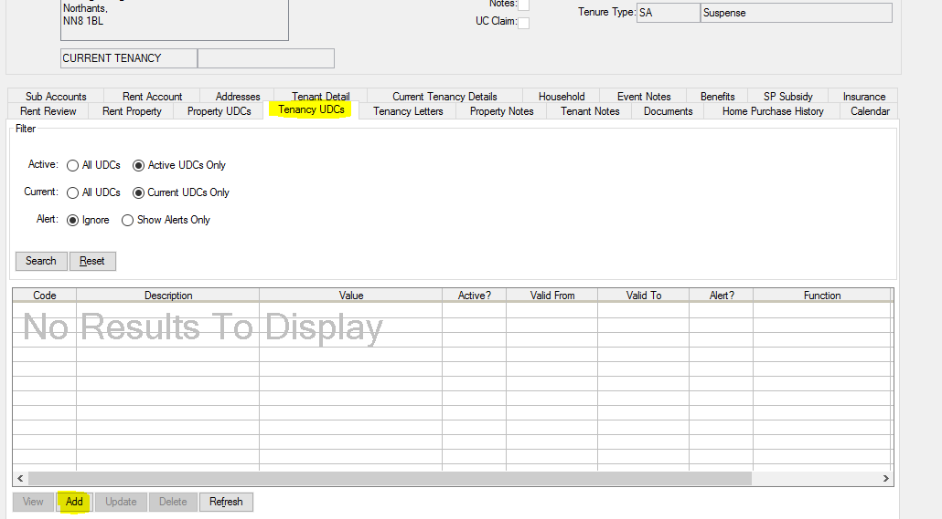  Fill in fields  UDC Type: CAT  Valid From: today’s date is fine. As long as it’s not in the future the system will report the cat as present in the household  Valid To: leave blank
12.1.2 | Notes: If there is a requirement for additional detail, this is where you need to write it  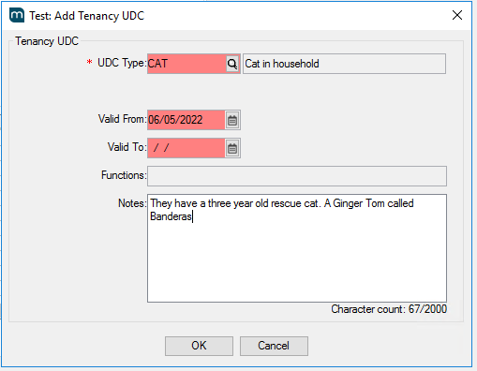  Click OK  NB. If there are multiple cats you will need to add one UDC per cat
12.1.3 | Adding a Dog to a Household  Go to the Tenancy. Click on the Tenancy UDCs Tab. Click Add  Fill in fields  UDC Type: DOG  Valid From: today’s date is fine. As long as it’s not in the future the system will report the cat as present in the household  Valid To: leave blank
12.1.4 | Notes: If there is a requirement for additional detail, this is where you need to write it  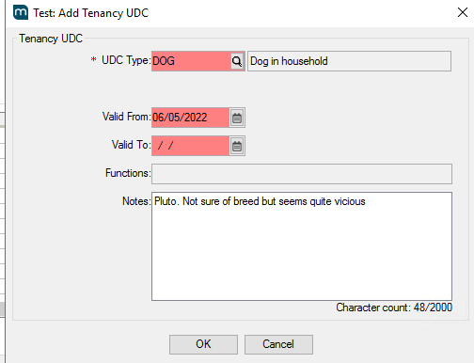  Click OK  NB. If there are multiple dogs you will need to add one UDC per dog
12.1.5 | Adding an Exotic pet (uncaged) to a Household  Go to the Tenancy. Click on the Tenancy UDCs Tab. Click Add  Fill in fields  UDC Type: EXOTIC  Valid From: today’s date is fine. As long as it’s not in the future the system will report the cat as present in the household  Valid To: leave blank
12.1.6 | Notes: If there is a requirement for additional detail, this is where you need to write it  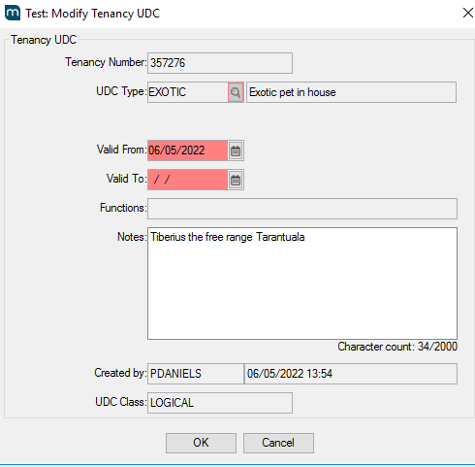  Click OK
12.1.7 | Removing a pet from a household.  Go to the Tenancy. Click on the Tenancy UDCs Tab. Highlight the pet you wish to remove. Click UPDATE  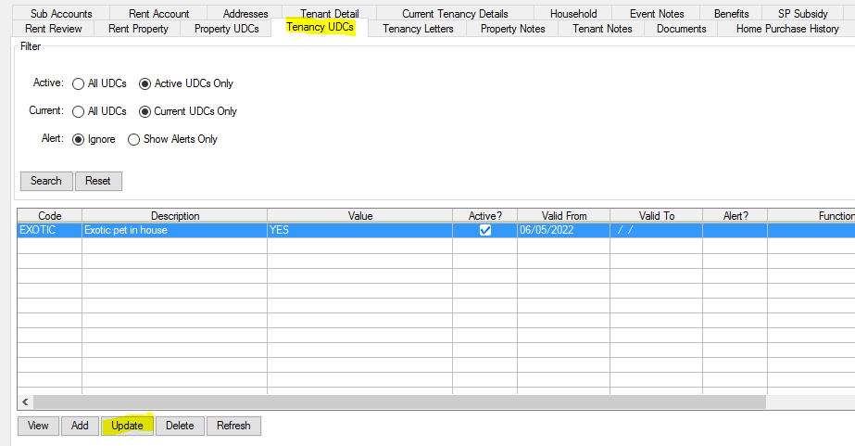  Add a date in Valid To and click OK.  Tip - if you put in yesterday’s date the UDC will disappear straight away as the date is in the past!  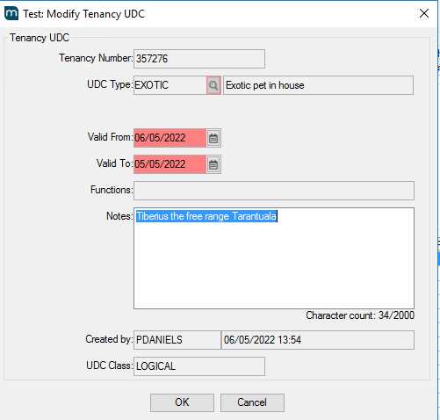
12.2 | Do not use the DELETE option to remove a pet from a household. Only use DELETE if you are correcting an error.

