How to Join TPAS as a tenant

Go to www.tpas.org.uk and click on join at top of page

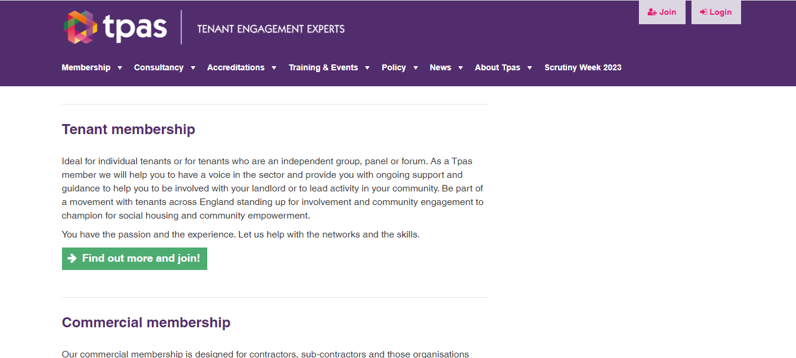

Scroll down to tenant membership and click on find out more and join

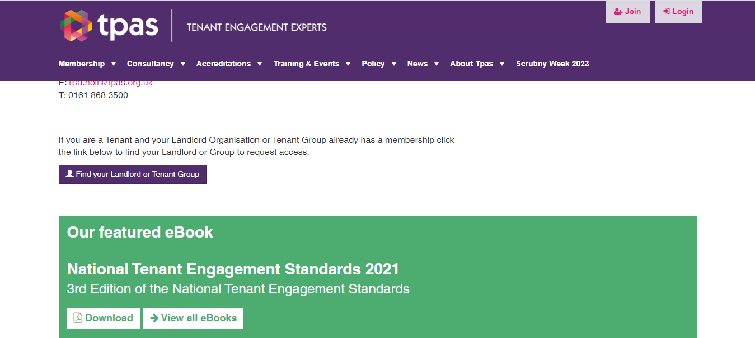

Scroll down to bottom of page until you see find your landlord or tenant group button and click on it
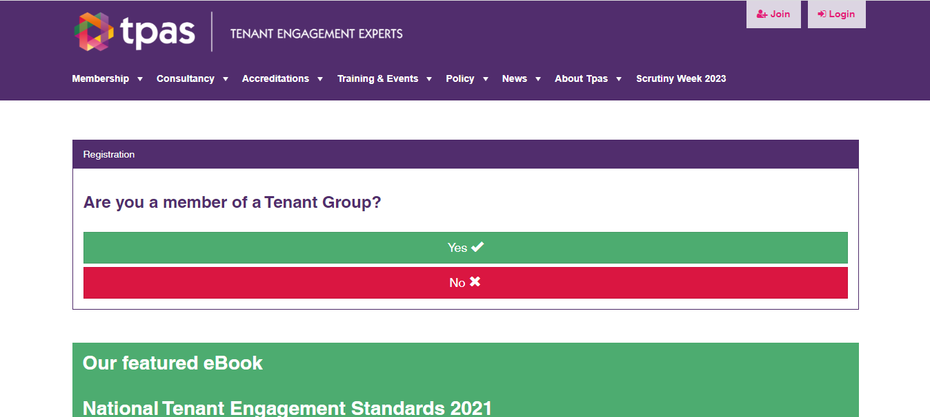
Select No when it asks you if a member of a tenant group
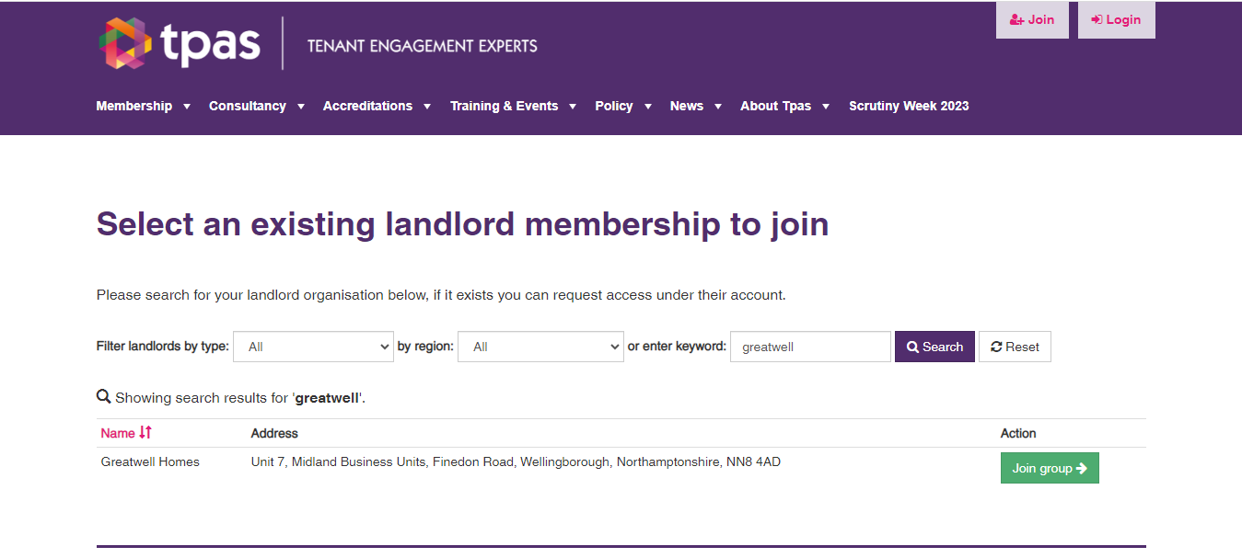
It will come up with a list of landlords, type in greatwell and press search, It will come up with greatwell home, then can click on join group. Fill out your details, click join and will now be a member of TPAS
